Lecture 13 – Exercises and Solutions

Question 1

- At what substrate concentration would an enzyme with a k_{cat} of 30.0 s⁻¹ and a K_{m} of 0.008 mol/L operate at one-fifth of its maximum rate?
- Determine the fraction of the maximum reaction rate (V_{o}/V_{max}) that would be obtained at the following concentrations of [S]: 0.5 K_{m,} 2 K_{m,} 5 K_{m}
- Suppose an uncompetitive inhibitor is introduced with a α’=5. How does the inhibitor affect the maximum velocity V_{max} ​ and what is the new V_{max} ​ in the presence of the inhibitor? Assume that the enzyme concentration is 50 nmol/L.

Answers:

a) To find the substrate concentration we use the Michaelis-Menten equation:

$$\frac{V_{max}}{5} = \frac{V_{max}[S]}{K_{m} + [S]}$$

Solving the equation for [S] [S] = K_{m} / 4 = 0.008 / 4 = 0.002 M

b) For [S] = K_{m}/2:
$$\frac{V_{0}}{V_{max}} = \frac{\frac{K_{m}}{2}}{K_{m} + \frac{K_{m}}{2}} = \frac{1}{3}= 0.33$$

For [S] = 2 K_{m}: Fraction of V_{max} = 0.67
For [S] = 2 K_{m}: Fraction of V_{max} = 0.83

c) V_{max} (without inhibitor) = k_{cat} x [E_{t}] = 30 x 50 x 10⁻⁹ = 1.5 x 10⁻⁶ M s⁻¹

With uncompetitive inhibition, when the Km << [S] we can approximate the formula:

$$V_{0} = \frac{V_{max}[S]}{K_{m} +'[S]}$$
To Vmax apparent = Vmax/ α’

V’_{max} = 1.5/5 = 3 x 10⁻⁷ M s⁻¹

Question 2

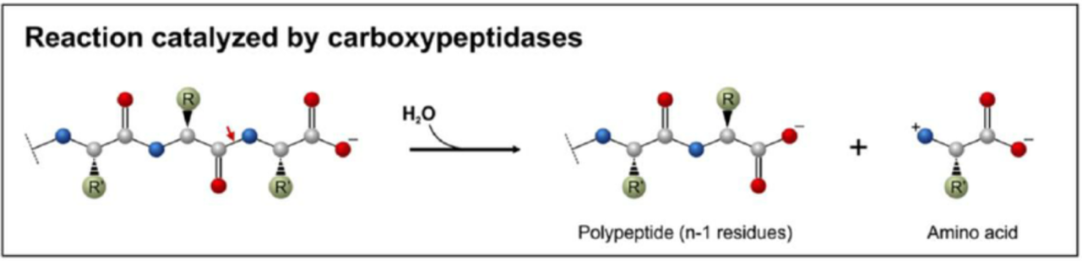

The active site of the enzymes is usually constituted by a pocket in the surface of the enzyme with amino acid chains binding the substrate and catalysing the involved reaction. The enzyme carboxypeptidase cleaves carboxy-terminal amino acids out of its peptide substrates. Carboxypeptidase is constituted by a single peptide chain of 307 amino acids. The two catalytically essential amino acids in carboxypeptidase are Arg-145 and Glu-270.

a) If carboxypeptidase was a perfect alpha helix how far away would be these amino acids?
b) Explain how these two amino acids (so far away in the enzyme sequence) can catalyse a reaction taking place in the range of few nanometers
c) If only these 2 amino acids are involved in catalysis why is carboxypeptidase constituted by 307 residues?

Answers:
a)
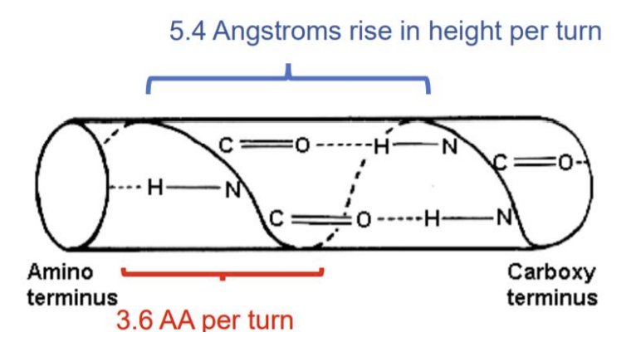

5.4Å per helical turn
3.6 amino acids per helical turn

5.4/3.6 = 1.5Å per amino acid
270-145 = 125 There are 125 amino acids between Arg-145 and Glu-270
125 x 1.5Å = 187.5Å Distance between the 2 residues if the protein was a perfect α-helix

b) The folding of the protein brings the 2 catalitically essential amino acids in proximity, to a much smaller distance than in a perfect α-helical protein

c) The rest of the protein sequence is important to maintain the folding, bringing the catalytic amino acids closer and forming the binding pocket for the substrate. This configuration provides the ideal environment for enzyme catalysis

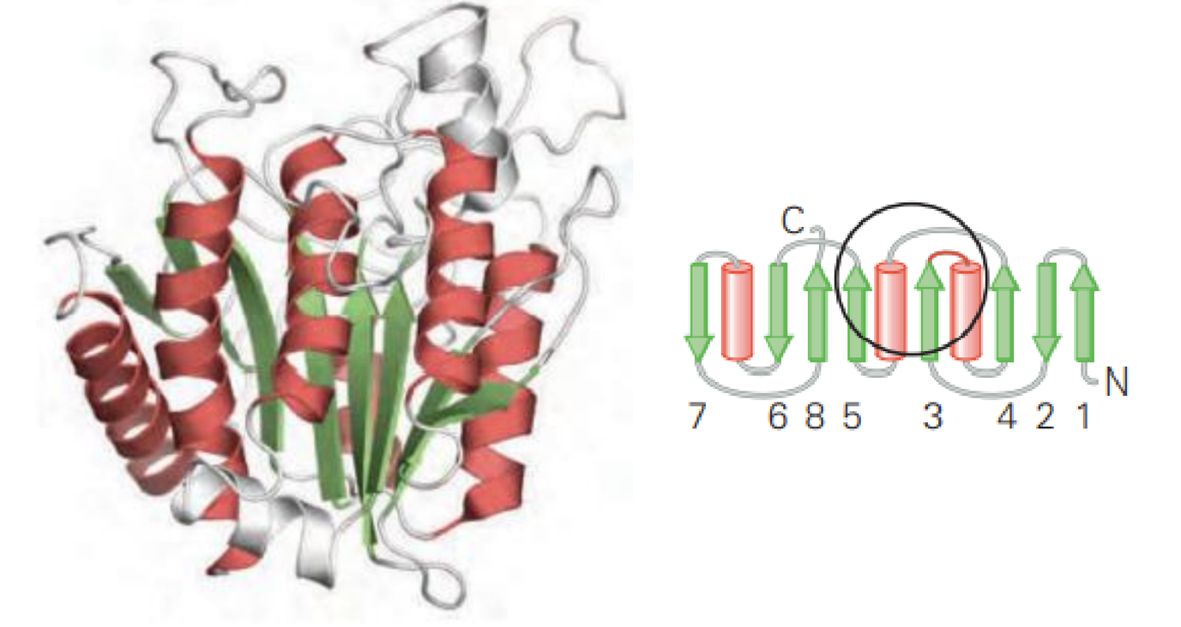

Question 3

Which of the following effects would be brought about by an enzyme catalysing the simple reaction:

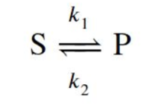
Where ${K'}_{eq}=\frac{[P]}{[S]}$

- Decreased K’_{eq}
- Increased k₁
- Increased ΔG‡ (E_{A})
- Decreased ΔG‡ (E_{A})
- Increased K’_{eq}
- More negative ΔG^{’o}
- Increased k₂

Answer:
b), d) and g)

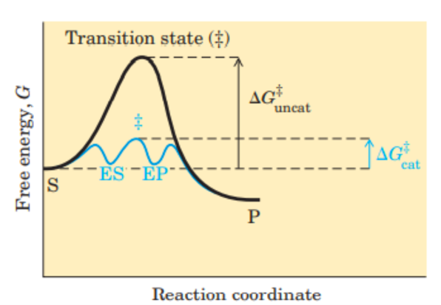
Question 4

Which of the following statements about enzyme-substrate binding is correct?
A) Enzyme-substrate binding is always an irreversible process.
B) Enzymes and substrates bind through a covalent bond in most reactions.
C) The enzyme’s active site is specific for a particular substrate.
D) Substrate binding occurs at random sites on the enzyme.

What is the primary function of an enzyme in a chemical reaction?
A) To stabilize the transition state, leading to a higher activation energy of the reaction.
B) To decrease the activation energy, thereby increasing the reaction rate.
C) To change the equilibrium constant of the reaction to favor substrate formation.
D) To bind its substrate with high affinity, forming a stable enzyme-substrate complex.

What happens to the reaction rate when the substrate concentration is much higher than the Michaelis constant ([S]>>K_{m})?
A) The reaction rate increases linearly with increasing substrate concentration.
B) The reaction rate is directly proportional to the substrate concentration.
C) The reaction rate is at its maximum value
D) The reaction rate is slower than at higher substrate concentrations due to substrate inhibition.

Which of the following statements about enzyme inhibitors is true?
A) Competitive inhibitors decrease the V_{max} of the enzyme.
B) Non-competitive inhibitors increase the K_{m}, but do not affect the V_{max}.
C) Competitive inhibitors can be partially overcome by increasing substrate concentration.
D) Non-competitive inhibitors bind to the enzyme-substrate complex, leading to an increase of the K_{m} and a decrease of the V_{max}.
Question 5
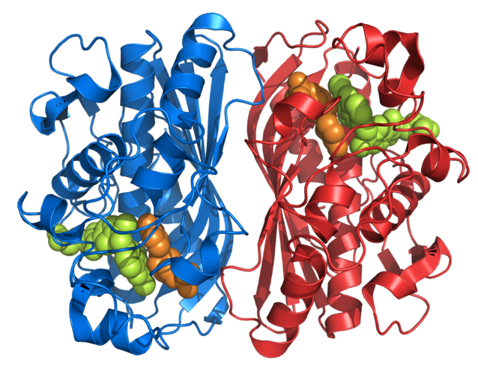

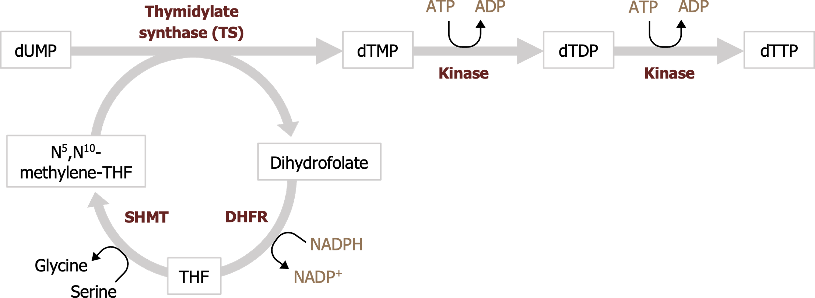

The enzyme thymidylate synthase (TS) catalyzes the reductive methylation of 2'-deoxyuridine 5'-monophosphate (dUMP) to 2'-deoxythymidine 5'-monophosphate (dTMP), a key building block for DNA. This reaction is crucial for DNA replication and repair, making TS an important target in cancer treatment. Researchers have found that the K_{m} for dUMP is 4µM and the kcat of the enzyme is 20 min⁻¹.

- In an experiment, the [dUMP] used was 6mM, and the initial velocity (V₀) was 480 nM min⁻¹. What was the concentration of TS used in in this experiment?
- In a second experiment, the enzyme concentration [TS] is 0.5 µM and V₀ = 5 µM min⁻¹. What was the [dUMP] in this experiment?
- You are developing a new chemotherapic drug that acts as a competitive inhibitor of TS with an α = 10. In an experiment with [E_{t}] as in exercise 5.a, but different [dUMP], an amount of the inhibitor is added that reduces the V₀ to 240 nM min⁻¹. What is the [dUMP] in the experiment?

Answers:
a)
$$V_{max}=k_{cat}[E_{t}]$$

$$V_{0} = \frac{k_{cat}[E_{t}][S]}{K_{m} + [S]}$$

$${[E}_{t}] = \frac{V_{0}(K_{m}+[S])}{k_{cat}[S]}$$

E_{t} = 480 x (4 x 10⁻⁶ + 6 x 10⁻³)/ (20 x 6 x10⁻³) = 24nM

b)
$$V_{0} = \frac{k_{cat}[E_{t}][S]}{K_{m} + [S]}$$
rearrange the equation to solve for [S]

[S] = 5 x10⁻⁶ x 4 x10⁻⁶ / (20 x 0.5 x10⁻⁶ – 5 x10⁻⁶) = 4µM

c)
$$V_{0} = \frac{k_{cat}[E_{t}][S]}{K_{m} + [S]}$$

[S] = 240 x10⁻⁶ x 4 x10⁻⁶ x 10/ (20 x 24 x10⁻⁹ – 240 x10⁻⁶) = 40µM

Question 6

The enzyme urease enhances the rate of urea hydrolysis at pH 8.0 and 20 °C by a factor of 10¹⁴. If a given quantity of urease can hydrolyse a given quantity of urea in 3 min at pH 8.0 and 20 °C, how long would it take for this amount of urea to be hydrolysed under the same conditions in the absence of urease?

Answer:

t _{w/o urease} = 10¹⁴ t _{urease}

t _{w/o urease} = 10¹⁴ x 3 min ~5.7 x 10⁸ years

Question 7:

You are studying the kinetics of different compounds containing radioactive elements, with particular interest in iodine-123 (¹²³I) which is important for medical imaging of tyroid function and follows a first order decay kinetics into ¹²³Te. A 15 μg sample of ¹²³I has decreased to 7.5 μg after 13 hours. After how much time will it decay to less than 0.95 μg?

¹²³I -> ¹²³Te
Answer:

Time of half-life (t_{1/2}) = 13 hours so decrease by half every 13 hours as this is first order kinetics. You can then use the equation describing first order kinetics:

[¹²³I_{t}] = [¹²³I₀] * e^{-k t} = [¹²³I₀] * e^{-0.693 t / t1/2}

If you solve for t:

t = ln ([¹²³I_{t}] / [¹²³I₀]) / (-0.693/t_{1/2}) = -2.759 / -0.053 = 52.05 hours

Question 8: Alternative plots of kinetic reactions

One transformation of the Michaelis-Menten equation is the Lineweaver-Burk, or double reciprocal, equation. Multiplying both sides of the Lineweaver-Burk equation by Vmax and rearranging gives the Eadie-Hofstee equation:

$$V_{0}=(-K_{m})\frac{V_{0}}{[S]}+V_{max}$$

A plot of V₀ vs. V₀/[S] for an enzyme-catalyzed reaction is shown below and results in a linear dependance. The curve in gray was obtained in the absence of inhibitor while the curves in black correspond to cases where inhibitor was added.

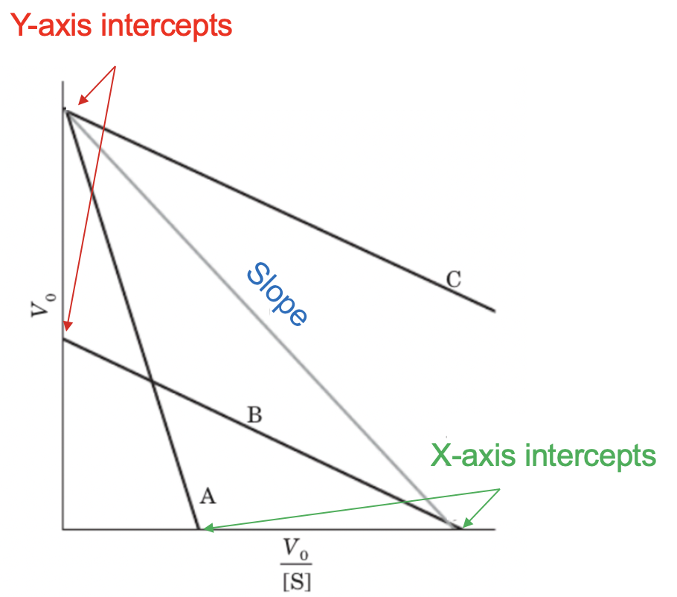

a) In this plot, what would the slope, X- and Y-axis intercepts correspond to?
b) Which reaction has the highest Km?
c) Which of the other curves (A,B or C) shows the enzyme activity when a competitive inhibitor is added to the reaction mixture?

Answers:
a) This is a typical linear equation with the following general form:

Y = Slope * X + Y_{intercept}

From the equation you can see that the Slope corresponds to (-Km).
Equivalently, Y_{intercept} = V_{max} (This can easily be derived by assuming X = 0)

At the X_{intercept} the value of Y axis (V₀) will be 0. Replacing that into the equation above you get that this intercept corresponds to the case when the value of X-axis (V₀/[S]):
X_{intercept} = V_{max}/Km

b) The highest Km is reaction A because it has the “steepest” negative slope (Slope = -Km).

c) The correct curve is A because competitive inhibitors increase the K_{m} (lower slope) but they don’t change the V_{max}

